 | Dalhousie University  Faculty of Computer Science | 

CSCI 3171 Network Computing Summer-2017

Assignment 2 Submission [50 marks]

Name: Jesse Carter ID: B00694792

Answers to Task 1: run nslookup
- Run nslookup to obtain the IP address of a Web server in Africa. What is the IP address of that server?

197.189.196.146

- Run nslookup to determine the authoritative DNS servers for a university in Asia. List one server shown in the result.

dns-x.sinet.ad.jp internet address=150.100.18.10

- Insert a screenshot of your command window/terminal showing the above commands and their results.

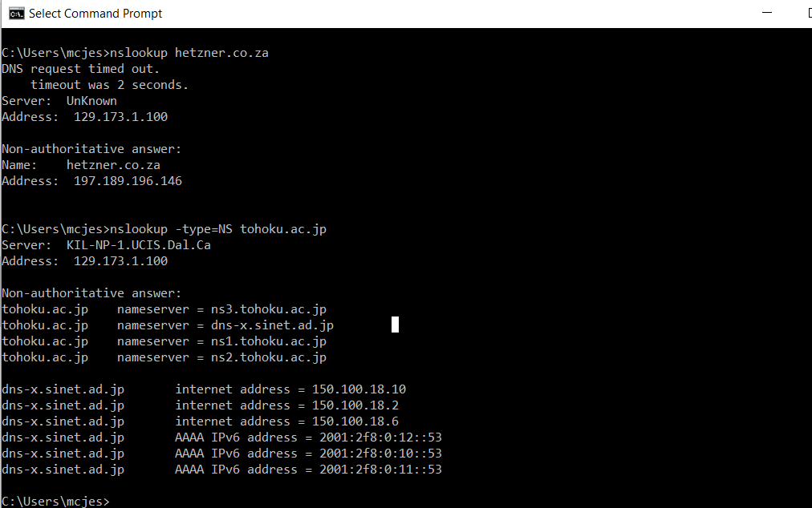

Answers to Task 2: Tracing DNS with Wireshark
- What is the IP address of your computer? Use ipconfig to determine this.

134.190.171.168

- Attach a screenshot of your command prompt/terminal window for question 4 above.

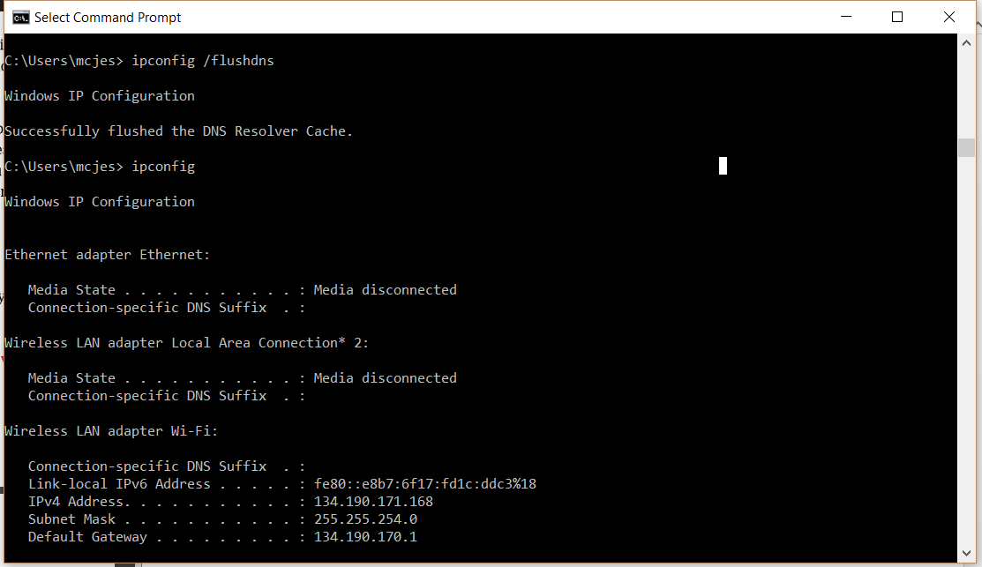

- From the wireshark trace, locate the first DNS query and response messages for the above web page (this might be the third DNS query in the trace). Are these sent over UDP or TCP?

They are sent over UDP (evidence by the User Datagram Protocol header)

- Insert a screenshot of your wireshark window with the DNS query selected.

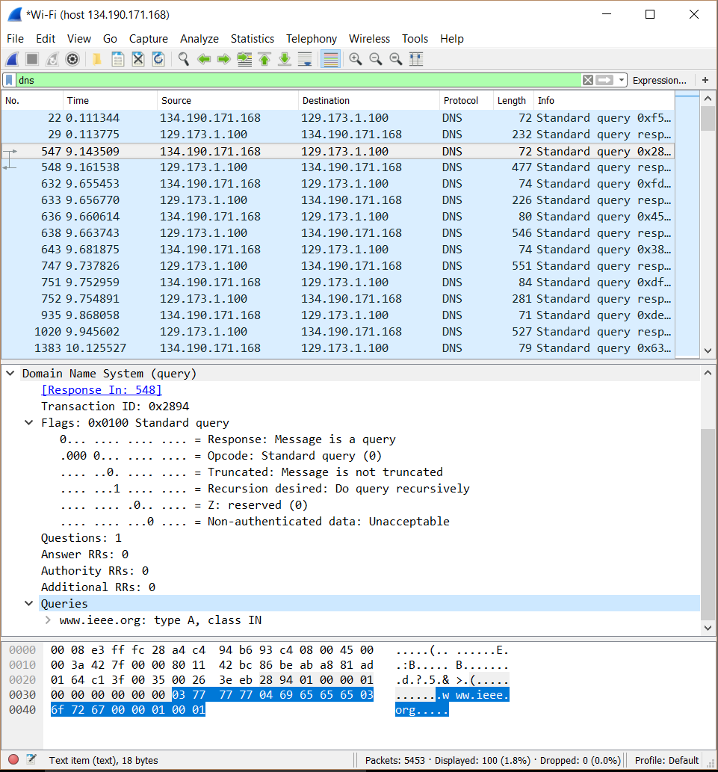

- What is the destination port for the DNS query message? What is the source port of DNS response message? How are these related?

DNS Query Dst Port: 53
DNS Response Src Port: 53

They are the same port!

- To what IP address is the DNS query message sent? Use ipconfig to determine the IP address of your local DNS server. Are these two IP addresses the same? Why or why not?

Dst: 129.173.1.100
Local DNS: 129.173.1.100

They are the same IP Address, this is because the query is going to the local DNS server to be fed into the DNS Server Hierarchy to return the ip address of the requested site (www.ieee.org)

- Examine the DNS query message. What “Type” of DNS query is it? Does the query message contain any “answers”?

It is a “type A”, there are no “Answers”

- Examine the DNS response message. How many “answers” are provided? What do each of these answers contain? Attach a screenshot of these answers.

3 Answers are provided:

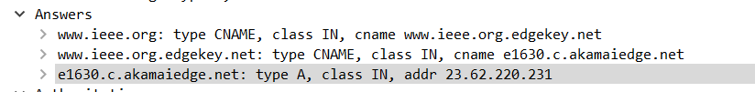

The first answer is the actual address of the requested site, the second and third answers are something else.

- Save the packet trace as IEEEDNS.pcapng (or the default file extension for Wireshark). You will need to upload this with your answer.

It has been saved
Answers to Task 3: nslookup Trace
- Provide a screenshot of your command prompt/terminal window clearly showing the command and its result.

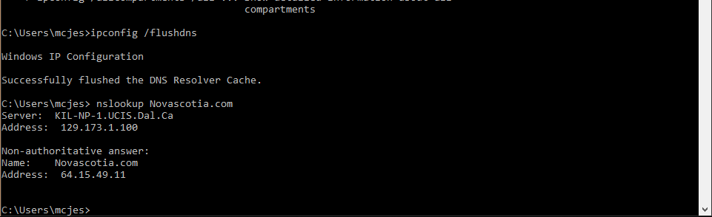

- What is the destination port for the DNS query message? What is the source port of DNS response message?

DNS Query: Dst: 53

DNS Response: Src: 53

- To what IP address is the DNS query message sent? Is this the IP address of your default local DNS server?

DNS Query: Dst: 129.173.1.100

Yes it is, the KIL-NP-1.UCIS.Dal.ca server!

- Examine the DNS query message. What “Type” of DNS query is it? Does the query message contain any “answers”?

It is a “type A” and does not contain any “Answers”

- Examine the DNS response message. How many “answers” are provided? What do each of these answers contain?

1 Answer is provided, it is the address of Novascotia.com: addr 64.15.49.11

- Provide a screenshot clearly showing the “answers” in the DNS response message.

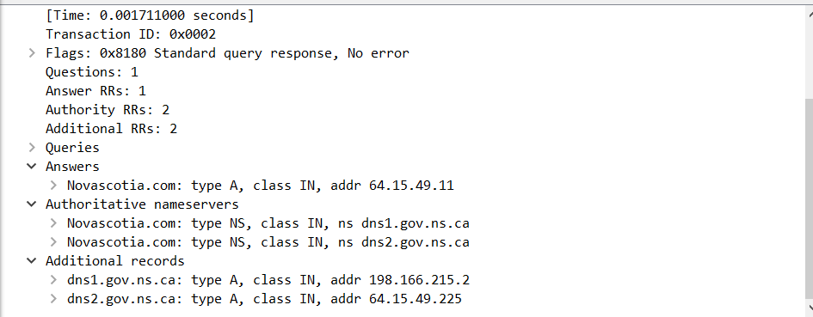

- Save the packet trace as NS1DNS.pcapng (or the default file extension for Wireshark). You will need to upload this with your answer.

- Provide a screenshot of your command prompt/terminal window clearly showing the command and its result.

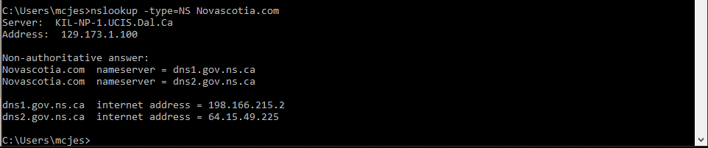

- To what IP address is the DNS query message sent? Is this the IP address of your default local DNS server?

Dst: 129.173.1.100

It is the default local DNS server

- Examine the DNS query message. What “Type” of DNS query is it? Does the query message contain any “answers”?

It is a “type NS” with no “Answers”

- Examine the DNS response message. What nameservers does the response message provide? Does this response message also provide the IP addresses of these nameservers?

ns dns2.gov.ns.ca and ns dsn1.gov.ns.ca

Yes it does, addr 198.166.215.2 and addr 64.15.49.225 respectively

- Provide a screenshot clearly displaying the “answers” in the DNS response message.

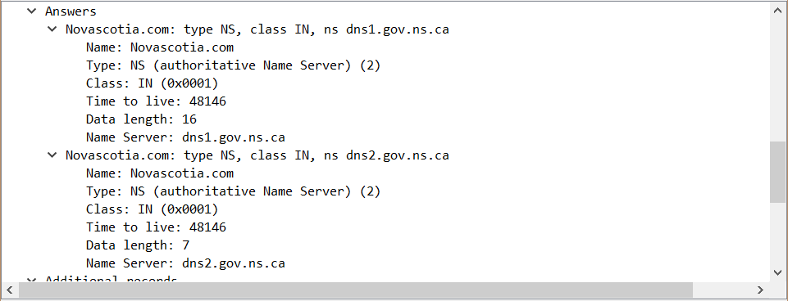

- Save the packet trace as NS2DNS.pcapng (or the default file extension for Wireshark). You will need to upload this with your answer.

